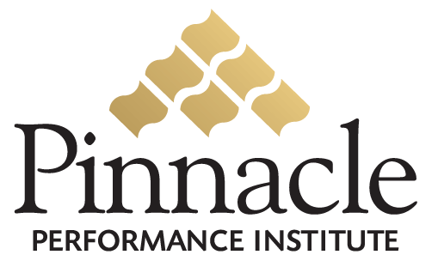

Secret Desires of Small Business Owners

Small business owners leaving the safety net of the mother corporation soon discover that their options for training and developing their employees are not as plentiful. If the secret wishes of small business owners and business unit managers were to be published they’d probably sound something like this:
- I wish I had affordable access to Fortune 500 quality training.
- I wish I had industry/company specific training on product knowledge, policies & procedures and sales techniques.
- I wish I had full access to an e-learning solution on an as-needed basis with no risks, no setup fees, no long-term commitments, and no technical skills required.
- I wish I could manage the quality compliance requirements by having all my employees certified to be qualified and equipped with the skills to excel at their responsibilities.
- Oh, and by the way, I wish I could have all this for just pennies a day.

This would be an unbelievable solution for a small business or a business unit, but of course, this isn’t really possible… or is it?

